C/CAG
City/County Association of Governments
of San Mateo County

Atherton • Belmont • Brisbane • Burlingame • Colma • Daly City • East Palo Alto • Foster City • Half Moon Bay • Hillsborough • Menlo Park • Millbrae • Pacifica • Portola Valley • Redwood City • San Bruno • San Carlos • San Mateo • San Mateo County •South San Francisco • Woodside

Date: December 12, 2016

To: Council Members from San Mateo County Cities and Towns, and Members of the San Mateo County Board of Supervisors
All City/County Managers

From: Alicia C. Aguirre, C/CAG Chair

Subject: Solicitation of Elected Officials to Serve on C/CAG’s Bicycle and Pedestrian Advisory Committee and Legislative Committee

The City/County Association of Governments of San Mateo County (C/CAG) will have two vacant seats on the Bicycle and Pedestrian Advisory Committee (BPAC) and two vacant seats on the Legislative Committee for elected officials of City Councils and/or the Board of Supervisors. Individuals must be an elected official on one of the twenty City and Town Councils in San Mateo County or an elected official on the San Mateo County Board of Supervisors.

Individuals wishing to be considered for appointment to either the BPAC or Legislative Committee should send a letter of interest by no later than January 20, 2017 to:

Sandy Wong, C/CAG Executive Director
City/County Association of Governments
555 County Center, 5th Floor
Redwood City, CA 94063
or e-mail to slwong@smcgov.org

About the Bicycle and Pedestrian Advisory Committee (BPAC):

The BPAC provides advice and recommendations to the full C/CAG Board on all matters relating to bicycle and pedestrian facilities planning, and selection of projects for state and federal funding. This Committee has approximately six meetings per year. The BPAC meets on the fourth Thursday of the month from 7:00 p.m. to 9:00 p.m. in San Mateo City Hall.

About the Legislative Committee:

The Legislative Committee provides advice and recommendations to the full C/CAG Board on matters dealing with State Legislation, ballot measures, and positions to take on specific bills. The Committee is also the liaison with C/CAG’s Lobbyist in Sacramento. The Committee meets at 5:30 p.m. on the second Thursday of the month, immediately before the regular C/CAG Board meeting. The Committee generally cancels its meetings when the State Legislature is in recess.

If you would like to be considered for either the BPAC or Legislative Committee, please submit your letter of interest by January 20, 2017. Appointments will be considered at the February 9, 2017 C/CAG Board of Directors meeting.

If you have any questions about either the BPAC or Legislative Committee, or have any questions about the appointment process, please feel free to contact the respective C/CAG Staff as follows:

For BPAC: For Legislative Committee:
Eliza Yu Jean Higaki
650-599-1453 650-599-1462
eyu@smcgov.org jhigaki@smcgov.org

Sincerely,

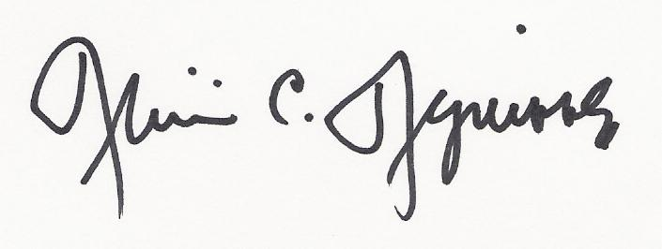
Alicia C. Aguirre
C/CAG Chair

