Safe Routes to School (SRTS) and Green Streets Infrastructure Pilot Program

Project Application

Section I: General Project and Applicant Information
General Project Information
Sponsor Agency:
Project Title:
Amount of Funds Requested ($): | Grant Request Capital Cost Match (15% min of Capital Cost)
Note: Minimum request is $100,000 and maximum award is $250,000 per project location (2 project limit per applying jurisdiction)
Participating School District:
Participating School Name(s)
& Address(es):
Contact information of District Safe Routes to School Coordinator:
Project Manager
Name:
Title:
Agency:
Phone Number:
E-mail Address:
Mailing Address:
City, State, Zip:

Section II: Existing Conditions
A. Project Need
1. Description of project location and boundaries:

In Attachment II, include a map of the project area showing the project location, the location of the benefitting school(s), and any relevant land use or transportation information. Also include a walking or biking route map to the school if applicable. Include existing condition project photos.
2. Why is the project needed? What are the current risks and/or obstacles (physical or perceived) to walking and/or bicycling to and from your school site(s), including for children with disabilities?

3. How will the project address stormwater management needs at this site and what additional water quality and community benefits will be provided in terms of flow and/or volume capture, flood mitigation, or aesthetic enhancement?

4. Proposed project locations should have been previously mentioned in a City/County Walk Audit or Pedestrian Bike Plan. Include the name of the document and relevant page numbers, as well as an electronic link.

If not mentioned in Walk Audit or Pedestrian Bike Plan, proposed projects must be within a ½ mile radius of school and reasonable justification for the project should be provided, such as accident statistics or other data as to why the particular location is deemed appropriate.
5. Does the proposed project provide direct benefits to an existing local or countywide plan, or directly support goals, objectives, or projects in other plans, including bike and pedestrian master plans, community-based transportation plans, complete or sustainable streets plans, etc.? If so, provide supporting evidence of the connection between the proposed project and such plans.

Provide photos indicating existing conditions and include in your Attachment II section.

Section III: Proposed Project

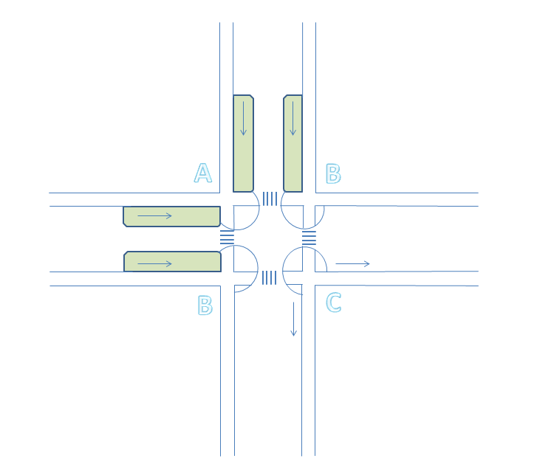
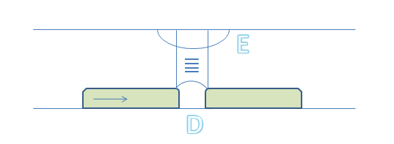
Project Scenarios:
A – Low point with flow from both directions toward the intersection treated by two stormwater curb extensions with a pedestrian bulbout and crossings
B – Flow from one direction going around the corner, treated with a single stormwater curb extension adjacent to a pedestrian bulbout and crossings
C – High point with flow running in both directions away from the intersection with a standard bulb-out, crossings and stormwater features located elsewhere
D – Mid-block crossing with stormwater curb extensions on either or both side(s) of crossing
E – Mid-block crossing with a standard bulbout and stormwater features located elsewhere

A. Project Components
1. Use the diagram on previous page to explain the proposed SRTS and stormwater infrastructure elements, demonstrating how the proposed components will achieve the SRTS and stormwater goals of this pilot program.

For example, you might describe the proposed project as a combination of scenarios A and D, where you have two stormwater curb extensions and a pedestrian bulb-out at a sump condition at one corner of an intersection and a stormwater curb extension and bulb-out at a mid-block crossing.

If the project includes an alternative to the general scenarios shown in the diagram above, describe the SRTS and stormwater infrastructure components, illustrating the integration of pedestrian and stormwater infrastructure and indicating the direction of stormwater flow.
2. Include as Attachment III, a simple design concept of all proposed project features. Concepts should include a map delineating the drainage areas for each stormwater feature (either an estimate of the overall drainage area, including adjacent parcels, or at least the crown to curb delineation). At minimum use the 4% of drainage area sizing criteria for calculating the proposed dimensions of the stormwater features. More detailed sizing analysis via the C.3 Technical Guidance combined flow/ volume sizing calculations is encouraged, which can be accessed through the Pilot Program webpage (http://ccag.ca.gov/opportunities/call-for-projects/). Where the standard C.3.d sizing criteria from the Municipal Regional Stormwater Permit cannot be met, please still include the estimated treatment capacity of the facilities for evaluation. Concepts should also show the location of existing storm drain inlets in the project area.
3. Does the project concept include educational signage to inform the public about stormwater management/SRTS goals?

B. Logistics
1. Do you have Right of Way clearance for all property involved with your project? You must confirm you have the necessary Right of Way in order to receive a grant. | ☐ Yes  ☐ No

C. Operations and Maintenance
1. Provide a description of how long-term operations and maintenance for the completed facilities will be provided – identify the entity or department responsible for long-term operations and maintenance and the plan for funding to ensure sustained operations and maintenance.

See guidance document and the Pilot Program webpage (http://ccag.ca.gov/opportunities/call-for-projects/) for resources.

D. Project Readiness
1. Indicate the Readiness to Proceed for the proposed project. Projects that demonstrate a high degree of readiness to proceed will be awarded more points in the scoring process.

Section IV: Project Timeline and Budget
A. Timeline and Budget
1. Please provide in Attachment IV a proposed project budget and timeline, including all project deliverables. The budget should include a minimum 15% cash only local match from the project sponsor applied to the capital costs (see application guidelines for example under Funding Details). The proposed budget must also show a breakdown of estimated capital costs for SRTS and stormwater components with the goal of an equal cost distribution between the two program components, but no greater than a 60/40 split. For guidance on providing an estimated cost breakdown, see the example Preliminary Cost Breakdown Table appended to this application and linked from the Pilot Program webpage (http://ccag.ca.gov/opportunities/call-for-projects/) . Applicants may provide a different cost table if preferred. The proposed budget may include a 10% contingency for construction.

Section V: School and Community Support
A. School and Community Support
1. Does this project have the support from the participating school? If so, include letter(s) in Attachment I. |  | ☐ Yes – Attach letter of support from school district  ☐ No – School district support is mandatory, grant proposals without a letter of support will not be considered
2. Does this project have local community support or involvement? If so, include supporting documentation in Attachment I. |  | ☐ Yes – Attach any supporting documentation (e.g. letters of support from local city council, major property owners, neighborhood associations, community groups, transit operators, etc.)  ☐ No
3. Describe any existing programs at the participating school(s) (including SRTS initiatives) that educate, encourage, or enhance walking or bicycling to school. This information can be provided by the principal of the school or SRTS coordinator and include information pertaining to any:

- Walking/biking/safety curriculum taught by the school
- Frequency of and participation in encouragement programs
- Anything else that the school/district has done that makes walking and biking easier, safer, or the preferred transportation choice
Attachments
At minimum include the following attachments with your application:
Attachment I – School District and Community Letters of Support
Attachment II – Project Area Map, Existing Conditions Photos, Surrounding Land Use Information and Reference to Relevant Walk Audit or Pedestrian/Bike Plan
Attachment III – Project Concept and Sizing Calculations
Attachment IV – Preliminary Timeline and Budget with Cost Breakdown Table

