REQUEST FOR PROPOSALS

FOR
CONSULTANT SERVICES TO CONDUCT AN EQUITY STUDY
FOR THE SAN MATEO COUNTY US 101 EXPRESS LANES

The San Mateo County Express Lanes Joint Powers Authority (SMCEL-JPA) is seeking a firm to conduct an Equity Study for the San Mateo County US 101 Express Lane Implementation.

Project Background:

The San Mateo County US 101 Express Lanes Project is a multi-agency project initiated to reduce traffic congestion and encourage carpooling and transit use on US Highway 101 (US 101) in San Mateo County.

The project will address congestion and improve mobility on US 101 by creating 22 miles of express lanes from Interstate-380 (I-380), in San Bruno, to the San Mateo County/Santa Clara County border. It will incentivize the use of public transit, carpools, and other shared-ride options. The San Mateo County US 101 Express Lane Project will then seamlessly connect to the express lanes1 being constructed in Santa Clara County.

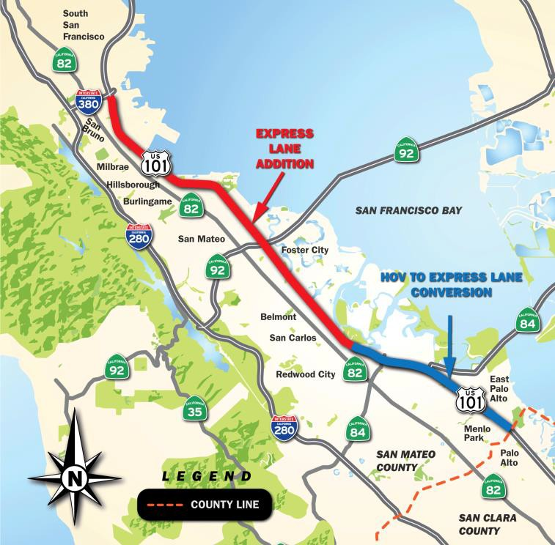

1 http://www.vta.org/projects-and-programs/highway/silicon-valley-express-lanes
In San Mateo County, from Whipple Avenue to the I-380 interchange, this project converts some of the existing northbound and southbound auxiliary lanes into through-lanes by extending them through the interchanges and adding a toll system to the far-left lanes to make them express lanes. From the Santa Clara border to Whipple Avenue, the existing carpool lanes will be converted to express lanes. Together, this will create two 22-mile long express lanes in San Mateo County. Construction began in March 2019, with completion estimated by late 2022, including the implementation and testing of the tolling system. Project funding comes from a variety of sources, including SB 1 funds, other state, and local funds.

The goals of this project are; to provide continuous traffic management in each direction from the terminus of the planned Santa Clara County express lanes to north of I-380 in San Mateo County, reduce congestion, encourage carpooling and transit use, improve travel time reliability, minimize degradation of the general purpose lanes, increase person throughput, and to apply technology to help manage traffic.

Background

In February 2019, upon the recommendation of the San Mateo Express County Lane Ad Hoc committee, both the City/County Association of Governments of San Mateo County (C/CAG) Board of Directors and the San Mateo County Transportation Authority (SMCTA) Board adopted resolutions to retain ownership of the San Mateo County Express Lanes Project and contract with Bay Area Infrastructure Financing Authority (BAIFA) to operate the express lanes on their behalf. Both Boards also agreed to form a Joint Powers Authority to exercise the shared rights and responsibilities as a joint owner of the Express Lanes project.

Both C/CAG and SMCTA Boards subsequently approved the Joint Exercise of Powers Agreement that created the SMCEL-JPA, pursuant to the California Joint Exercise of Powers Act, to oversee the operations and administration of the project, and to jointly exercise the Project ownership rights of C/CAG and SMCTA.

The SMCEL-JPA became effective on June 1, 2019 and has an Executive Council that consists of both Executive Directors of C/CAG and SMCTA, as well as a Policy/Program Manager (PPM) that provides policy and program advice to the SMCEL-JPA Board and oversees its implementation.

On June 28, 2019, the SMCEL-JPA Executive Council submitted an application to the California Transportation Commission (CTC) for Toll Authority for the US 101 Express Lane project, from the San Mateo/Santa Clara County border to Interstate 380 in San Bruno. CTC held a public meeting on July 25, 2019 in San Mateo County to receive comments from the public on the proposed Express Lanes Project. On August 14, 2019, during the regular CTC meeting held in San Jose, CTC Commissioners unanimously approved SMCEL-JPA’s application for Toll Facility.
Caltrans has begun construction of the Project. The existing HOV lanes from the San Mateo County/ Santa Clara County border to Whipple Avenue will be converted into express (managed) lanes, and an additional lane will be added to U.S. Highway 101 in each direction from Whipple Avenue to I-380.
Because having express lanes is new to San Mateo County, SMCEL-JPA wishes to conduct an Equity Needs Assessment of the US 101 Express Lanes to report on findings, as well as make recommendations for an Equity Program.

Scope of Work:
The Scope of Work for the Equity Study Consultant may include, but is not limited to:
Deliverables:
- Baseline Conditions Technical Report
- Needs Assessment Findings
- Equity Program Recommendation

Activities:
- Develop a baseline condition technical report to provide an equity needs assessment of the US 101 Express Lanes project area and San Mateo County as a part of the regional express lanes network. This assessment should include, at minimum:
  - Assist SMCEL-JPA to define the Equity Study problem statement, set objectives, and recommend the methods to study equity and tolling. This shall inform activities to manage the Equity Study, including all public, stakeholder, and agency involvement.
    - Develop and implement the Equity Study schedule, including deliverable and presentation milestones, with guidance and approval from the SMCEL-JPA PPM.
    - Identify and engage, under guidance and approval from the SMCEL-JPA PPM, stakeholder, agency, and community groups, to gather input and feedback throughout the Equity Study.
    - Assist the SMCEL-JPA PPM in coordinating and managing an Equity Steering Committee (ESC):
      - Schedule, and facilitate ESC meetings once every two months. This schedule shall include milestones, such as submittals and meetings designated for review and input.
      - With guidance and approval of the SMCEL-JPA PPM, draft and distribute meeting agendas, collateral, and presentation materials.
  - Review applicable local, regional, state, and federal transportation equity rules, regulations, standards, and studies to include, but not limited to:
    - Existing or ongoing equity studies, such as the US 101 Mobility Action Plan and Transform’s “Pricing Roads, Advancing Equity” report.
    - Existing Bay Area express lanes operators’ current measures and future plans to address equity.
    - Potential issues, conflicts, or opportunities from various implementation scenarios of equity and tolling policies at the regional level.
    - National tolling operators’ equity policies to provide policy context and understanding of opportunities and challenges.
  - Determine potential equity impacts to measure, including but not limited to:
    - Economic burden or lack of resources to receive benefits from the facility.
    - Mobility constraints, such as travel time burdens, value of time comparison, and other transportation issues and how they affect employment, health, education, and other access.
  - Analyze current and projected demographic and GIS data to identify US 101 corridor and Express Lane users, including equity groups.
    - The Direct Impact Area (DIA) shall include communities within 1 mile of the corridor.
    - The Indirect Impact Area (IIA) shall include San Mateo County.
    - The demographic analysis should include, but not be limited to, relevant data such as income, race, ethnicity, disability, age, limited English proficiency (LEP), educational attainment, mode of travel to and from work, time leaving home from work, automobile ownership, among others.
  - Analyze readily available current and projected transportation demand and traffic data along the US 101 corridor.
    - Apply select link analysis to assess trip patterns and impacts on travel time and destination accessibility.
    - Analyze value of time/willingness to pay by income distribution and trip purpose to inform the development of policies that are sensitive to behavioral differences of low-income travelers.
  - Refine the Equity Study goals, objectives, and study area (DIA, IIA) boundaries based on analysis, as necessary.
  - Develop and implement a public engagement strategy that identifies target audiences to involve equity populations based on the analysis and refined study area. This first of two public engagement steps shall identify existing or potential community transportation issues regarding the US 101 Express Lanes facility. Consultant shall work with guidance and seek approval of the SMCEL-JPA PPM.
These activities should include, but are not limited to:
    - Focus groups
    - Surveys
    - Public workshops or pop-ups
    - Stakeholder interviews or workshops
    - Produce and distribute all necessary collateral for public engagement, such as FAQs, fact sheets, web-site content, social media, presentations, etc.
    - Responsible for booking all venues and staffing all public meetings which may include presenting at meetings
    - Provide translation services for all collateral in Spanish and Chinese and other languages if necessary, and meeting translation services if needed
    - Record minutes of meetings and produce report with findings of public outreach.
  - Synthesize geographic, demographic, transportation, and public engagement findings to complete a needs assessment of current and future equity concerns that may be affected by the US 101 Express Lanes post-opening.
    - Analyze and document findings to determine impact and severity, if applicable, in comparison to applicable standards, when available, or relative comparisons.
    - Use significance testing to determine whether studied equity impacts are affected by minority or low-income status.
    - Use significance testing to determine whether studied impacts are affected by the managed lanes project.
    - Submit the Baseline Conditions Technical Report to the SMCEL-JPA for review. Revise according to comments and submit for approval

- Develop a memorandum that incorporates the findings from the existing conditions technical report and guidance from the Equity Steering Committee. This memorandum shall include the recommendation for an Equity Program for the US 101 Express Lanes:
  - Draft an Equity Program for the US 101 Express Lanes to include:
    - Strategies to address and mitigate potential equity concerns.
    - Implementation plan for the recommended mitigation strategies.
    - Monitoring plan to ensure effective mitigation, post-opening, that define key performance indicators (KPI) of the mitigations' effectiveness.
  - Plan and implement the second phase of the public engagement strategy. Using new or the same engagement methods, as appropriate, this phase shall gather public perceptions and input to refine all components of the draft Equity Program.
  - Synthesize public input, stakeholder feedback, ESC guidance, and the Baseline Conditions Technical Report into one Policy Memorandum to recommend an Equity Program for the US 101 EL.
  - Submit the Baseline Conditions Technical Report, Needs Assessment Findings and Equity Program Recommendation to the ESC, SMCEL-JPA, C/CAG, and SMCTA Boards for review. Revise according to comments and submit for approval.
  - Be prepared to conduct up to 10 additional presentations to stakeholder groups, including, but not limited to, government agencies, public interest groups, and community organizations.

Qualifications:

  - Key personnel should have extensive knowledge and experience with conducting equity studies for toll systems and/or similar projects, as well as public engagement and information campaigns. The removal or substitution of key personnel from the project (key personnel as determined by SMCEL-JPA), shall not be allowed without the expressed written consent of SMCEL-JPA.
  - Knowledge and experience with data gathering and analysis, conducting surveys and public engagements, preparing reports and other pertinent documents.
  - Ability to work collaboratively with staff and other consultants in developing revenue forecasts per the results of data gathered and analyzed.
  - Have knowledge of and ability to comply with Federal and State agreements, rules, and regulations related to highway operations and Express Lanes, including CFR 23.
  - Have ability to make detailed analyses of data and information and make recommendations.
  - Excellent communication skills, ability to speak in front of large audiences and write, effectively.
  - Skill in using modern office suite software, with emphasis on management, financial, operations and maintenance systems/software.

Submittals:
Respondents should provide information on the following:
Organization and Experience:
- Background and brief history - Provide proposed key staff resumes, clearly indicating experience, educational qualifications, professional affiliations, and the number of years with each employer.
- The Consultant must provide sufficient staffing levels, both in numbers and appropriately qualified personnel, to adequately address the scope, magnitude and number of assignments.
  - Describe your team’s understanding of the Express Lane Project.
  - Describe your team’s approach and methodology to conducting the technical analysis and developing the Baseline Conditions Technical Report.
  - Describe your team’s approach and methodology to conducting the technical analysis and developing the recommendation for an Equity Program.
  - Provide a preliminary schedule that indicates how you will achieve 2b and 2c within 12 months following a Notice to Proceed.
  - Describe your team’s relevant experience on Equity Study for Express Lane Projects and/or similar projects. Specify where the experience was gained, specific job duties and responsibilities, process taken and final outcome.
  - Describe your team’s experience presenting to community leaders, governmental and regulatory agencies, employees and/or other groups, and the public. What do you feel are key points to the success of addressing a diverse group of people?
  - Provide samples of previous completed Equity Study.

Price Proposal:

- Provide hourly rates for the services described in this RFP. These rates will be considered in evaluating proposals and may form the basis of negotiations for a fee in an agreement, or be used for purposes of assessing monthly progress draws. Also, include rates for any support staff, if required.
- Advise if the hourly fees include travel time or any overhead consultant intends to charge SMCEL-JPA.
- Fees should assume the following relative to projects and disbursements. Costs that are to be part of the quoted hourly rate and are not reimbursable include but are not limited to:
  - (Monthly) costs for cell phone service;
  - Respondent’s home office costs for telephone service,
  - Internet service and the like, office rentals,
  - Office equipment, etc.
- Reimbursable disbursements may include:
  - Only those other charges identified as reimbursable by the Respondent in the specific project proposal and accepted as reimbursable in advance by SMCEL-JPA. No markup is applicable to any reimbursable disbursements.

Each submittal must include a clear and concise response to the items listed above. The combined responses to all items should not exceed eight (8) pages. A cover memo or letter, sample of previous reports, resumes and additional supporting material, included as appendix, will not count toward the eight-page limit. The submittal must be received NO LATER THAN 4:00 p.m. on Tuesday, February 11, 2020.

Submit six (6) hard bound copies, plus one electronic copy on flash/thumb drive, of your response to this RFP to:
Van Dominic Ocampo, P. E.
Transportation System Coordinator
C/CAG
555 County Center, 5th Floor
Redwood City, CA. 94063.

Professional Liability Insurance:

The Consultant and its Sub-consultant(s) shall each purchase and maintain a Professional Liability insurance policy for negligent acts, errors and omissions that provides minimum liability coverage of $1,000,000 per claim and annual aggregate. The Consultant's policy shall cover negligent acts, errors or omissions by the Consultant and Sub-consultant(s) engaged by Consultant and other any person or entity for whom the Consultant is legally liable arising out of the rendition of services pursuant to the Contract. Each Sub-consultant's policy shall cover negligent acts, errors or emissions of the Sub-consultant. SMCEL-JPA reserves the right to adjust liability coverage on a project-by-project basis as it deems appropriate.

Selection Process:

A selection committee will evaluate proposals received. By responding to this RFP, respondents agree and acknowledge that SMCEL-JPA has the sole right of decision as to award of an Agreement(s), or not, in this matter.

SMCEL-JPA reserves the right to disqualify any, and all, responses to this RFP based on the accuracy of the information provided in the submittal, as well as potential conflict of interest.

SMCELJPA seeks the best combination of value and service. This information is provided for general guidance only, and SMCEL-JPA reserves the unqualified right to modify or eliminate any aspect of this process at any time, without notice to Respondents.

The proposal evaluation will include but not be limited to the following criteria (listed in no particular order):
    - Qualification of the Firm(s)
    - Understanding of the project and SMCEL-JPA’s needs
    - Proposed approach to the project
      - Availability of consultant
    - Comparable, demonstrated experience and success in providing Equity Study for similar size and complex to Express Lanes Project.
    - Knowledge of Federal and/or State Departmental (Caltrans/ CTC/ State) regulations.
    - On-Time & On-Budget performance on similar previously completed projects.
    - Outcome of previous Public Outreach and information drives.
    - Clients and other references
    - Clarity and organization of the proposal.
    - Interview
    - Others

Questions:
Direct all inquiries in writing or email, to Van Dominic Ocampo, C/CAG Transportation System Coordinator, (650) 599-1460, email vocampo@smcgov.org, before 4:00 pm, on Friday, January 24, 2020.

Interviews and Negotiations:
A selection committee will review all responses to the RFP and may or may not meet with selected respondents. The granting of interviews shall be in the sole and unfettered discretion of SMCEL-JPA staff. If invited, only the personnel that make-up the project team are invited to the interview. Also, submission of a proposal does not assure an interview will be granted, nor shall the failure to grant an interview necessarily disqualify a respondent from further consideration. Respondents shall be responsible for all travel and related costs involved in attendance for an interview.

SMCEL-JPA may enter negotiations with one or more respondents, at SMCEL-JPA staff’s sole and unfettered discretion. SMCEL-JPA staff reserves the right to negotiate with more than one proponent concurrently or consecutively and to add to or delete from the submission any particular item or items required in the RFP.

If SMCEL-JPA and the selected respondents are unable to negotiate an agreement, SMCEL-JPA may begin or continue negotiations with any other proponent, at any time. Negotiations may take place with selected respondents without the obligation to re-call submissions or provide an opportunity for other respondents to submit proposals based on the same changes. No proponent shall have any rights against SMCEL-JPA arising from such negotiations.
A clause shall be included in all contracts reserving the right to terminate the contract at any time at the SMCEL-JPA’s sole discretion.

